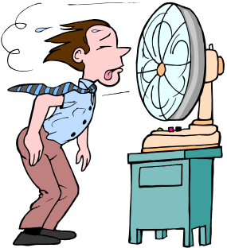
Heat Activities
Activity 1
- Set up 4 beakers containing equal amounts of water. Beaker 1 should contain icy water, beaker 2 hot water (but not too hot!) and beakers 3 and 4 should contain water at room temperature.
- Place your left hand into beaker 1 and your right hand into beaker 2. Leave your hands in the beakers for 1 minute then place your left hand into the beaker 3 and your right hand into beaker 4.
- Record your observations in the space below.

Activity 2
- Collect the samples of materials provided (wood, metal, glass, plastic, Styrofoam).
- Place your palms flat on the various surfaces and compare how cold they feel.
- Arrange the materials in order from cold to warm and list them below:

- Place the thermometer on each material and record the temperature in the space below.

- What do you notice? Try to explain these results.

Activity 3
- Fill a beaker with hot water and another with the same amount of cold water.
- When the water is still, put a drop of food colouring into the centre of each beaker.
- Record your observations in the space below:

